**Cells are Made of Organelles**

Complete the Venn diagram below for the organelles that the three cell types contain, using the organelles listed on the right. Then match each organelle with their function.

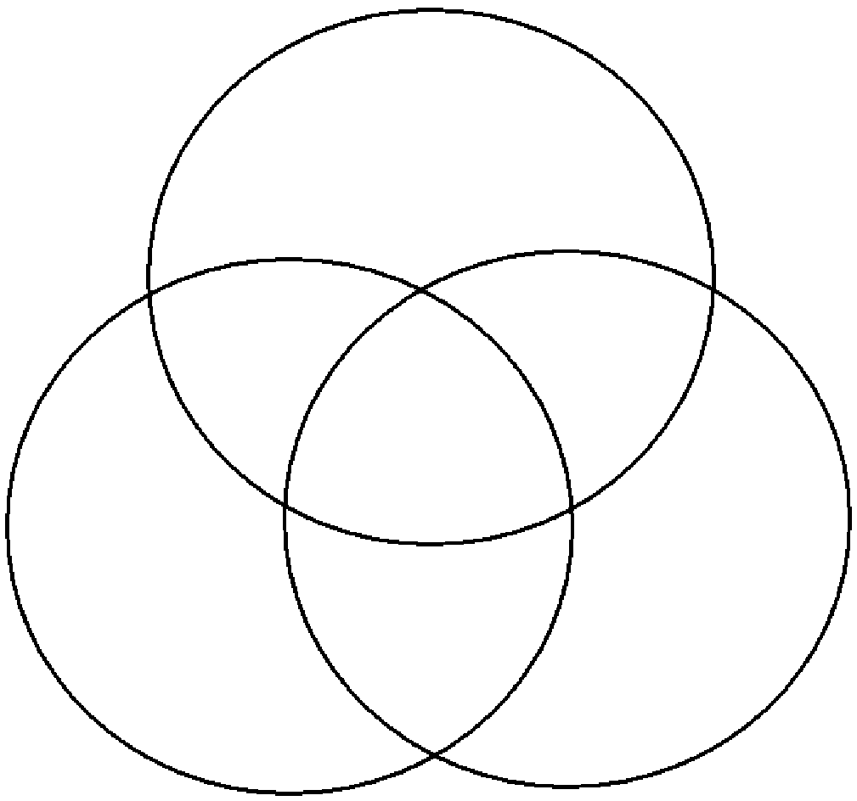

Fungi Cell

Animal Cell

Plant Cell

|  |  |  |
| --- | --- | --- |
| Golgi Body |  | 1. Exists outside the cell membrane, supports and protects the cell. |
| Nucleus |  | 1. Packages proteins inside the cell before they are sent to their destination. |
| Cell Membrane |  | 1. Contains chlorophyll to aid photosynthesis. |
| Cell Wall |  | 1. Allows materials to move through the cell. |
| Vacuole |  | 1. Gets rid of waste from the cell. |
| Ribosomes |  | 1. Produces proteins used by the body for growth and repair. |
| Endoplasmic Reticulum |  | 1. Releases energy from food. |
| Cytoplasm |  | 1. Contains the DNA of the cell. |
| DNA |  | 1. Provides the instructions for every job the cell needs to do. |
| Mitochondria |  | 1. Fluid inside the cell that provides structure and contains smaller parts of the cell. |
| Lysosomes |  | 1. Contains waste or chemicals. |
| Chloroplast |  | 1. Forms a barrier around the cell. |